**Angular Project code**

**Book Store**

Components

1.app.component.html

<!--The content below is only a placeholder and can be replaced.-->

<app-nav></app-nav>

<section>

<router-outlet></router-outlet>

</section>

<app-footerbar></app-footerbar>

2.nav.component.html

<nav class="navbar navbar-inverse navbar-fixed-top">

<div class="container-fluid">

<div class="navbar-header">

<a class="navbar-brand logo" style="color:white" routerLink="/" ><i class="fa fa-book" style="font-size:30px;color:white;"></i><strong>{{Apptitle}}</strong></a>

</div>

<ul class="nav navbar-nav" style="float:right">

<li><a routerLink="/">Home</a></li>

<li><a routerLink="/about">About</a></li>

<li><a routerLink="/search">Search</a></li>

<li><a routerLink="/admin">Admin</a></li>

</ul>

</div>

</nav>

3.(1)home.component.html

<div class="container-fluid" style=padding-top:40px>

<div id="myCarousel" class="carousel slide" data-ride="carousel">

<!-- Indicators -->

<ol class="carousel-indicators">

<li data-target="#myCarousel" data-slide-to="0" class="active"></li>

<li data-target="#myCarousel" data-slide-to="1"></li>

<li data-target="#myCarousel" data-slide-to="2"></li>

<li data-target="#myCarousel" data-slide-to="3"></li>

</ol>

<!-- Wrapper for slides -->

<div class="carousel-inner">

<div class="item active">

<img src="assets/z1.jpg" alt="Carousel" style="width:100%;">

</div>

<div class="item">

<img src="assets/z2.jpg" alt="Carousel" style="width:100%;">

</div>

<div class="item">

<img src="assets/z3.jpg" alt="Carousel" style="width:100%;">

</div>

<div class="item">

<img src="assets/z4.jpg" alt="Carousel" style="width:100%;">

</div>

</div>

<!-- Left and right controls -->

<a class="left carousel-control" href="#myCarousel" data-slide="prev">

<span class="glyphicon glyphicon-chevron-left"></span>

<span class="sr-only">Previous</span>

</a>

<a class="right carousel-control" href="#myCarousel" data-slide="next">

<span class="glyphicon glyphicon-chevron-right"></span>

<span class="sr-only">Next</span>

</a>

</div>

</div>

<div class="container-fluid" style="padding-top:50px;">

<div class="row">

<div class="col-xs-12 col-sm-12 col-md-12">

<div class="carousel carousel-showmanymoveone slide" id="itemslider">

<div class="carousel-inner">

<div class="item active">

<div class="col-xs-12 col-sm-6 col-md-2">

<a href="#"><img src="assets/avs.jpg" class="img-responsive center-block" ></a>

<h4 class="text-center">Now that you are rich</h4>

</div>

</div>

<div class="item">

<div class="col-xs-12 col-sm-6 col-md-2">

<a href="#"><img src="assets/i1.jpeg" class="img-responsive center-block"></a>

<h4 class="text-center">Eleven Minutes</h4>

</div>

</div>

<div class="item">

<div class="col-xs-12 col-sm-6 col-md-2">

<a href="#"><img src="assets/i3.jpg" class="img-responsive center-block"></a>

<h4 class="text-center">I love you</h4>

</div>

</div>

<div class="item">

<div class="col-xs-12 col-sm-6 col-md-2">

<a href="#"><img src="assets/i4.jpg" class="img-responsive center-block"></a>

<h4 class="text-center">Hold my hand</h4>

</div>

</div>

<div class="item">

<div class="col-xs-12 col-sm-6 col-md-2">

<a href="#"><img src="assets/i5.jpg" class="img-responsive center-block"></a>

<h4 class="text-center">If its not forever</h4>

</div>

</div>

<div class="item">

<div class="col-xs-12 col-sm-6 col-md-2">

<a href="#"><img src="assets/i7.jpg" class="img-responsive center-block"></a>

<h4 class="text-center">Chanakya Neeti</h4>

</div>

</div>

</div>

<div id="slider-control">

<a class="left carousel-control" href="#itemslider" data-slide="prev">

<span class="glyphicon glyphicon-chevron-left"></span>

<span class="sr-only">Previous</span>

</a>

<a class="right carousel-control" href="#itemslider" data-slide="next">

<span class="glyphicon glyphicon-chevron-right"></span>

<span class="sr-only">Next</span>

</a>

</div>

</div>

</div>

</div>

</div>

<div class="container" style=padding-top:40px>

<div class="row">

  <div class="col-md-12">

<div *ngFor="let Book of service.list">

      <div class="col-sm-6 col-md-4">

        <div class="thumbnail" >

<a routerLink="/productindex/{{Book.Bookid}}">

<h4 class="text-center"><span class="label label-info">{{Book.BookCategory}}</span></h4>

<div class="bookWrap">

<div class="col-lg-3" style="margin-left:-20px">

<img class="cover"src="{{Book.BookImage}}" name="profilepic2" style="width:350px;height:300px;"/>

</div>

<div class="spine"></div>

</div>

          <div class="caption">

            <div class="row">

<h4 class="text-center"><b>{{Book.BookTitle}}</b></h4>

              <div class="col-md-6 col-xs-6">

<p style="text-align:center"><b> Published : {{Book.PublicationYear}}</b></p>

              </div>

              <div class="col-md-6 col-xs-6 ">

<p style="color:red;text-align:center"><b> PRICE : {{Book.BookPrice}}</b></p>

              </div>

            </div>

</div>

</a>

</div>

      </div>

</div>

</div>

</div>

</div>

<!-- <div class="container-fluid">

<div class="col-lg-12">

<div *ngFor="let Book of service.list">

<div class="col-lg-3" style="padding:5px;border:1px solid pink;border-radius:30px;margin-left:100px;margin-top:30px">

<div style="padding:10px">

<a routerLink="/productindex/{{Book.Bookid}}">

<div class="bookWrap">

<div class="col-lg-3" style="margin-left:-20px">

<img class="cover" src="{{Book.BookImage}}" alt="Image" style="width:300px;height:300px;" />

</div>

<div class="spine"></div>

</div>

</a>

<div class="body">

<h5 style="text-align:center">{{Book.BookTitle}}</h5>

<p style="color:red;text-align:center"><b> PRICE :{{Book.BookPrice}}</b></p>

<div class="row">

<div class="col-md-6">

<a class="btn btn-color btnR zoom" style="margin-left:27px"

>

<span class="glyphicon glyphicon-shopping-cart">

</span>BUY NOW

</a>

</div>

<div class="col-md-6">

<a class="btn btnR zoom" style="margin-left:10px">

ADD TO CART</a>

</div>

</div>

</div>

</div>

</div> </div>

</div>

</div> -->

3.(2) [home.component.css](http://home.component.css)

.bookWrap {

margin: 8px auto;

height: 301px;

width: 230px;

position: relative;

-webkit-perspective: 1200px;

-moz-perspective: 1200px;

perspective: 1200px;

}

.book {

background: #000;

height: 346px;

width: 100px;

position: absolute;

left: 16px;

top: 0;

-webkit-transform-style: preserve-3d;

transform-style: preserve-3d;

-webkit-transition: -webkit-transform .5s ease 0s;

-moz-transition: -moz-transform .5s ease 0s;

transition: transform .5s ease 0s;

-webkit-border-radius: 0 7px 7px 0;

-moz-border-radius: 0 7px 7px 0;

border-radius: 0 7px 7px 0;

-webkit-perspective: 1200px;

-moz-perspective: 1200px;

perspective: 1200px;

}

.bookIntro {

-webkit-transform: rotateY(30deg);

-moz-transform: rotateY(30deg);

transform: rotateY(30deg);

}

.cover {

position: absolute;

left: 0;

top: 0;

height: 100%;

width: 230px;

max-width: 280px;

max-height: 346px;

-webkit-backface-visibility: hidden;

-moz-backface-visibility: hidden;

backface-visibility: hidden;

-webkit-border-radius: 0 4px 4px 0;

-moz-border-radius: 0 4px 4px 0;

border-radius: 0 4px 4px 0;

-webkit-transition: -webkit-transform .5s ease 0s, width .5s ease 0s;

-moz-transition: -moz-transform .5s ease 0s, width .5s ease 0s;

transition: transform .5s ease 0s, width .5s ease 0s;

-webkit-transform-origin: 0;

-moz-transform-origin: 0;

transform-origin: 0;

}

.cover:hover {

width: 100px;

-webkit-transform: rotateY(-20deg);

-moz-transform: rotateY(-20deg);

transform: rotateY(-20deg);

}

.spine {

width: 40px;

height: 344px;

position: absolute;

top: 0;

left: 0;

-webkit-transform: rotateY(90deg);

-moz-transform: rotateY(90deg);

transform: rotateY(90deg);

-webkit-transform-origin: 0;

-moz-transform-origin: 0;

transform-origin: 0;

}

3 .(3) [Home.componnet.css](http://Home.componnet.css)

import { Component, OnInit } from '@angular/core';

import { BookDetailsService } from 'src/app/share/book-details.service';

declare var $: any;

@Component({

selector: 'app-home',

templateUrl: './home.component.html',

styleUrls: ['./home.component.css']

})

export class HomeComponent implements OnInit {

constructor(public service:BookDetailsService) { }

ngOnInit() {

this.service.refreshList();

$(document).ready(function(){

$('#itemslider').carousel({ interval: 3000 });

$('.carousel-showmanymoveone .item').each(function(){

var itemToClone = $(this);

for (var i=1;i<6;i++) {

itemToClone = itemToClone.next();

if (!itemToClone.length) {

itemToClone = $(this).siblings(':first');

}

itemToClone.children(':first-child').clone()

.addClass("cloneditem-"+(i))

.appendTo($(this));

}

});

});

}

}

4.Admin.component.html

<app-booksdetailss></app-booksdetailss>

5.Booksdetailss.component.html

<div class="Jumbotron-container" style="padding-top:50px">

<h1 class="dipslay-4.text-center">Books Register</h1>

<div class="row">

<div class="col-md-4">

<app-booksdetail></app-booksdetail>

</div>

<div class="col-md-8">

<app-booklist></app-booklist>

</div>

</div>

</div>

6.(1) Booksdetail.componet.html

<form #form="ngForm" (submit)=OnSubmit(form) autocomplete="off">

<div class="form-group">

<label> Bookid :</label>

<input type="text" class="form-control" name="Bookid" [(ngModel)]="this.service.formData.Bookid" #Bookid=ngModel >

</div>

<div class="form-group">

<label> Book Title :</label>

<input class="form-control" name="BookTitle" [(ngModel)]="this.service.formData.BookTitle" #BookTitle="ngModel" required >

<div class="validation-error" *ngIf="BookTitle.invalid && BookTitle.touched">This field is required!</div>

</div>

<div class="form-group">

<label> Book Category :</label>

<input class="form-control" name="BookCategory" [(ngModel)]="this.service.formData.BookCategory" #BookCategory="ngModel" required >

<div class="validation-error" *ngIf="BookCategory.invalid && BookCategory.touched">This field is required!</div>

</div>

<div class="form-group">

<label> Book Info :</label>

<input class="form-control" name="BookInfo" [(ngModel)]="this.service.formData.BookInfo" #BookInfo="ngModel" required >

<div class="validation-error" *ngIf="BookInfo.invalid && BookInfo.touched">This field is required!</div>

</div>

<div class="form-group">

<label> Book Author :</label>

<input class="form-control" name="BookAuthor" [(ngModel)]="this.service.formData.BookAuthor" #BookAuthor="ngModel" required >

<div class="validation-error" *ngIf="BookAuthor.invalid && BookAuthor.touched">This field is required!</div>

</div>

<div class="form-group">

<label> Publication Year :</label>

<input class="form-control" name="PublicationYear" [(ngModel)]="this.service.formData.PublicationYear" #PublicationYear="ngModel" required >

<div class="validation-error" *ngIf="PublicationYear.invalid && PublicationYear.touched">This field is required!</div>

</div>

<div class="form-group">

<label> Book Price :</label>

<input class="form-control" name="BookPrice" [(ngModel)]="this.service.formData.BookPrice" #BookPrice="ngModel" required >

<div class="validation-error" *ngIf="BookPrice.invalid && BookPrice.touched">This field is required!</div>

</div>

<div class="form-group">

<label> Book Image :</label>

<input class="form-control" name="BookImage" [(ngModel)]="this.service.formData.BookImage" #BookImage="ngModel" required >

<div class="validation-error" *ngIf="BookImage.invalid && BookImage.touched">This field is required!</div>

</div>

<div class="form-group">

<button type="submit" class="btn btn-lg btn-block"> SUBMIT </button>

</div>

</form>

6.(2) Bookdetail.component.ts

import { Component, OnInit } from '@angular/core';

import { BookDetailsService } from 'src/app/share/book-details.service';

import { NgForm } from '@angular/forms';

import { ToastrService } from 'ngx-toastr';

import { BookDetails } from 'src/app/share/BookDetails.model';

@Component({

selector: 'app-booksdetail',

templateUrl: './booksdetail.component.html',

styleUrls: ['./booksdetail.component.css']

})

export class BooksdetailComponent implements OnInit {

public result:any;

Bookidd:number;

Book:BookDetails;

constructor(private service : BookDetailsService,private toastr:ToastrService) {

this.service.formData={

Bookid:null,

BookTitle:null,

BookCategory:null,

BookInfo:null,

BookAuthor:null,

PublicationYear:null,

BookPrice:null,

BookImage:null

}

this.result=this.service.list;

}

ngOnInit() {

this.resetForm();

this.service.refreshList();

}

OnSubmit(form:NgForm)

{ {debugger}

this.Bookidd=form.value.Bookid;

this.Book=this.service.list.find(e=>e.Bookid==this.Bookidd);

console.log(this.Bookidd);

if(this.Book==null)

{

this.InsertRecord(form);

}

else

{

this.UpdateRecord(form);

}

}

InsertRecord(form:NgForm)

{

this.service.postBookDetail(form.value).subscribe(res=>{

this.toastr.success("Inserted Successfully","Book Register");

this.resetForm(form)

this.service.refreshList();

});

}

UpdateRecord(form:NgForm)

{

this.service.putBookDetail(form.value).subscribe(res=>{

this.toastr.warning("Updated Successfully","Book Register");

this.resetForm(form)

this.service.refreshList();

});

}

resetForm(form?:NgForm)

{

if(form!=null)

{

form.resetForm();

this.service.formData={

Bookid:null,

BookTitle:null,

BookCategory:null,

BookInfo:null,

BookAuthor:null,

PublicationYear:null,

BookPrice:null,

BookImage:null

}

}

}

}

7. (1) BookList.component.html

<table class="table table-hover">

<tr>

<th>Image</th>

<th>Title</th>

<th>Category</th>

<th>Info</th>

<th>Author</th>

<th>Publication</th>

<th>Price</th>

<th></th>

</tr>

<tr *ngFor="let Book of service.list">

<td (click)=Populateform(Boook)><img src="{{Book.BookImage}}" name="profilepic2" height=150 width=150/>

</td>

<td (click)=Populateform(Book)>{{Book.BookTitle}}</td>

<td (click)=Populateform(Book)>{{Book.BookCategory}}</td>

<td (click)=Populateform(Book)>{{Book.BookInfo}}</td>

<td (click)=Populateform(Book)>{{Book.BookAuthor}}</td>

<td (click)=Populateform(Boook)>{{Book.PublicationYear}}</td>

<td (click)=Populateform(Boook)>{{Book.BookPrice}}</td>

<td><button (click)="onDelete(Book.Bookid)" class="btn btn-sm btn-outine-danger">X</button>

</tr>

</table>

7.(2) booklist.component.ts

import { Component, OnInit } from '@angular/core';

import { BookDetailsService } from 'src/app/share/book-details.service';

import { ToastrService } from 'ngx-toastr';

import { BookDetails } from 'src/app/share/BookDetails.model';

@Component({

selector: 'app-booklist',

templateUrl: './booklist.component.html',

styleUrls: ['./booklist.component.css']

})

export class BooklistComponent implements OnInit {

constructor(public service:BookDetailsService,public toastr:ToastrService) { }

ngOnInit() {

this.service.refreshList();

}

Populateform(Book:BookDetails)

{

this.service.formData=Object.assign({},Book);

}

onDelete(id:number)

{

if(confirm("Are you sure to Delete this record?")){

console.log(id);

this.service.deleteBook(id).subscribe(res=>

{

this.service.refreshList();

this.toastr.info("Deleted Successfully","Book Register");

});

}

}

}

8 .(1) search.component.html

<div class="container" style="padding-top:60px">

<div class="row">

<!-- <h2>Search..</h2> -->

<div class="col-lg-12">

<!-- <input type="text" class="form-control" [(ngModel)]=search #searchterm id="search" name="search" placeholder="Search Books by category..."/>

<input type="text" class="form-control" [(ngModel)]=search1 id="search1" placeholder="Search Books by title..." > -->

</div>

<div class="row">

<div class="col-md-5" >

<h4><b> Type Of Book:</b></h4>

<input type="text" class="form-control" [(ngModel)]="search" placeholder="Search Books by category..." />

</div>

<div class="col-md-5" style="margin-left:100px">

<h4><b> Name Of Book:</b></h4>

<input type="text" class="form-control"[(ngModel)]="search1" placeholder="Search Books by title... " />

</div>

</div>

<div style="padding-top:60px">

<div *ngFor="let Book of service.list|namefilterPipe:search|rankfilterPipe:search1">

<div class="items col-xs-12 col-sm-6 col-md-6 col-lg-6 ">

<div class="info-block block-info clearfix">

<a routerLink="/productindex/{{Book.Bookid}}"> <div class="square-box pull-left">

<img src="{{Book.BookImage}}" name="Image" style="width:170px;height:180px;">

</div></a>

<h4><strong>{{Book.BookTitle}}</strong></h4>

<h5>By- {{Book.BookAuthor}}</h5>

<p> Category:- {{Book.BookCategory}}</p>

<p>Price- {{Book.BookPrice}}</p>

<p> Publishing Year - {{Book.PublicationYear}}</p>

</div>

</div>

</div>

</div>

</div>

</div>

8.(2) search.component.ts

import { Component, OnInit } from '@angular/core';

import { BookDetailsService } from '../share/book-details.service';

@Component({

selector: 'app-search',

templateUrl: './search.component.html',

styleUrls: ['./search.component.css']

})

export class SearchComponent implements OnInit {

search:string;

search1:string;

constructor(public service:BookDetailsService) {

}

ngOnInit() {

this.service.refreshList();

// this.search="Fiction";

}

changeval(searchterm:string)

{

console.log(searchterm);

this.search1=searchterm;

// this.search=newvalue;

// console.log(this.search);

// search1=search;

// return search1;

console.log('search1: '+this.search1);

}

}

8.(3)search.component.css

.glyphicon-lg

{

font-size:4em

}

.info-block

{

border-right:5px solid #E6E6E6;margin-bottom:25px

}

.info-block .square-box

{

width:170px;height:180px;margin-right:22px;text-align:center!important;background-color:#20819e;

}

.info-block.block-info

{

border-color:#20819e

}

.info-block.block-info .square-box

{

background-color:#20819e;color:#FFF

}

9(1) productindex.component.html

<div class="container-fluid" style="padding-top:70px" >

<div class="row">

<div class="col-sm-6">

<div class="row">

<div class="col-sm-6" style="margin-bottom:30px">

<img src="{{b.BookImage}}" name="profilepic2" height=500 width=500/>

</div>

</div>

</div>

<div class="col-sm-6">

<div class="col-sm-7">

<div class="card-body p-9">

<h2 class="title mb-6"><b>{{b.BookTitle}}</b> </h2>

<h4 class="title mb-6">By- {{b.BookAuthor}}</h4>

<p class="price-detail-wrap">

<span class="price h3 text-warning">

<span >Rs </span><span class="num"> {{b.BookPrice}}</span>

</span>

</p> <!-- price-detail-wrap .// -->

<dl class="item-property">

<dt>Description</dt>

<dd><p> {{b.BookInfo}} </p></dd>

</dl>

<dl>

<dt>Published-</dt>

<dd> {{b.PublicationYear}}</dd>

</dl>

<hr>

<!-- <input type="submit" class="btn btn-lg btn-primary text-uppercase" value="Buy now"> -->

</div>

</div>

</div>

</div>

</div>

9(2) productindex.component.ts

import { Component, OnInit, OnDestroy } from '@angular/core';

import { ActivatedRoute } from '@angular/router';

import { BookDetailsService } from '../share/book-details.service';

import { BookDetails } from '../share/BookDetails.model';

@Component({

selector: 'app-productindex',

templateUrl: './productindex.component.html',

styleUrls: ['./productindex.component.css'],

})

export class ProductindexComponent implements OnInit {

sub:any;

Book:BookDetails[];

b:BookDetails;

constructor(private route: ActivatedRoute,public service:BookDetailsService) { }

ngOnInit() {

this.sub = this.route

.params

.subscribe(v =>this.dosearch(v['id']));

}

dosearch(id:number):any{

// this.Book=this.service.getdata();

this.service.refreshList();

console.log(id);

this.b=this.service.list.find(x=>x.Bookid==id);

console.log(this.b);

return this.b;

}

}

10.(1) about.compont.html

<div class="aboutus-section">

<div class="container">

<div class="row">

<div class="col-md-3 col-sm-6 col-xs-12">

<div class="aboutus">

<h2 class="aboutus-title">About Us</h2>

<p class="aboutus-text">You can buy books online on a variety of subjects like history and politics, science and technology, computer and medicine</p>

<p class="aboutus-text">literature, sports, travel and wildlife, music and cooking, etc. Such books will help you to enrich yourself with ideas and knowledge on

a particular segment and help you to put those ideas to work.</p>

<p style="font-size :large"><b>Phone NO:</b>+91-9999999999</p>

<a class="aboutus-more" routerLink="/">Book Store</a>

</div>

</div>

<div class="col-md-3 col-sm-6 col-xs-12">

<div class="aboutus-banner">

<img src="/assets/tree.JPG" />

</div>

</div>

<div class="col-md-5 col-sm-6 col-xs-12">

<div class="feature">

<div class="feature-box">

<div class="clearfix">

<div class="iconset">

<span class= "glyphicon glyphicon-heart-empty icon"></span>

</div>

<div class="feature-content">

<h4>Work with heart</h4>

<p>Books by All and for All From toddlers to grownups

, there is a book that can become the part of the book

shelf of every person.</p>

</div>

</div>

</div>

<div class="feature-box">

<div class="clearfix">

<div class="iconset">

<span class="glyphicon glyphicon-leaf icon"></span>

</div>

<div class="feature-content">

<h4>Reliable services</h4>

<p>If you are person who is preparing for various competitive examinations that are conducted nationwide,

you can buy books online and prepare yourself to beat everyone in the race to the top.</p>

</div>

</div>

</div>

<div class="feature-box">

<div class="clearfix">

<div class="iconset">

<span class="glyphicon glyphicon-cog icon"></span>

</div>

<div class="feature-content">

<h4>Great support</h4>

<p> School and college students can give

a professional touch to their assignments and projects with the help of the reference books available at BooksCart</p>

</div>

</div>

</div>

</div>

</div>

</div>

</div>

10.(2) about.component.cs

.aboutus-section {

padding: 90px 0;

}

.aboutus-title {

font-size: 30px;

letter-spacing: 0;

line-height: 32px;

margin: 0 0 39px;

padding: 0 0 11px;

position: relative;

text-transform: uppercase;

color: #000;

}

.aboutus-title::after {

background: #E31D3F none repeat scroll 0 0;

bottom: 0;

content: "";

height: 2px;

left: 0;

position: absolute;

width: 54px;

}

.aboutus-text {

color: #606060;

font-size: 13px;

line-height: 22px;

margin: 0 0 35px;

}

a:hover, a:active {

color: #ffb901;

text-decoration: none;

outline: 0;

}

.aboutus-more {

border: 1px solid #E31D3F;

border-radius: 25px;

color: #E31D3F;

display: inline-block;

font-size: 14px;

font-weight: 700;

letter-spacing: 0;

padding: 7px 20px;

text-transform: uppercase;

}

.feature .feature-box .iconset {

background: #fff none repeat scroll 0 0;

float: left;

position: relative;

width: 18%;

}

.feature .feature-box .iconset::after {

background: #E31D3F none repeat scroll 0 0;

content: "";

height: 150%;

left: 43%;

position: absolute;

top: 100%;

width: 1px;

}

.feature .feature-box .feature-content h4 {

color: #0f0f0f;

font-size: 18px;

letter-spacing: 0;

line-height: 22px;

margin: 0 0 5px;

}

.feature .feature-box .feature-content {

float: left;

padding-left: 28px;

width: 78%;

}

.feature .feature-box .feature-content h4 {

color: #0f0f0f;

font-size: 18px;

letter-spacing: 0;

line-height: 22px;

margin: 0 0 5px;

}

.feature .feature-box .feature-content p {

color: #606060;

font-size: 13px;

line-height: 22px;

}

.icon {

color : #E31D3F;

padding:0px;

font-size:40px;

border: 1px solid #E31D3F;

border-radius: 100px;

color:#E31D3F;

font-size: 28px;

height: 70px;

line-height: 70px;

text-align: center;

width: 70px;

}

11.(1).footerbar.component.html

<div class="bottom section-padding">

<div class="container">

<div class="row">

<div class="col-md-12 text-center">

<div class="copyright">

<p>© <span>2019</span> <a href="#" class="transition">BookStore</a> All rights reserved.</p>

</div>

</div>

</div>

</div>

</div>

11.(2)footerbar.compont.css

<div class="bottom section-padding">

<div class="container">

<div class="row">

<div class="col-md-12 text-center">

<div class="copyright">

<p>© <span>2019</span> <a href="#" class="transition">BookStore</a> All rights reserved.</p>

</div>

</div>

</div>

</div>

</div>

12(1) Sharefolder book-details.service.spec.ts

import { TestBed } from '@angular/core/testing';

import { BookDetailsService } from './book-details.service';

describe('BookDetailsService', () => {

beforeEach(() => TestBed.configureTestingModule({}));

it('should be created', () => {

const service: BookDetailsService = TestBed.get(BookDetailsService);

expect(service).toBeTruthy();

});

});

12(2) Sharefolder book-details.service.ts

import { Injectable } from '@angular/core';

import {BookDetails} from './BookDetails.model';

import {HttpClient, HttpHeaders, HttpParams} from '@angular/common/http';

import { Observable } from 'rxjs/internal/Observable';

import { getNumberOfCurrencyDigits } from '@angular/common';

@Injectable({

providedIn: 'root'

})

export class BookDetailsService {

formData:BookDetails;

list:BookDetails[];

readonly rootURL="http://localhost:54550/api"

constructor(private http:HttpClient) { }

postBookDetail(formData:BookDetails)

{

return this.http.post(this.rootURL+'/BookDetails',formData);

}

refreshList():void

{

this.http.get(this.rootURL+'/BookDetails')

.toPromise().then(res=>this.list=res as BookDetails[]);

}

putBookDetail(formData:BookDetails)

{

const headers = new HttpHeaders().set('content-type', 'application/json');

const params = new HttpParams().set('ID', formData.Bookid.toString());

{

return this.http.put<BookDetails>(this.rootURL+'/BookDetails/'+formData.Bookid,formData,{headers,params});

}

}

deleteBook(id:number)

{

return this.http.delete(this.rootURL+'/BookDetails/'+id);

}

getdata():any{

this.http.get(this.rootURL+'/BookDetails')

.toPromise().then(res=>this.list=res as BookDetails[]);

}

}

12(3) Sharefolder BookDeatils.model.ts

export class BookDetails{

Bookid:number;

BookTitle:string;

BookCategory:string;

BookInfo:string;

BookAuthor:string;

PublicationYear:number;

BookPrice:number;

BookImage:string;

}

13.(1) app.routing.modulel.ts

import { NgModule } from '@angular/core';

import { Routes, RouterModule } from '@angular/router';

import { HomeComponent } from './home/home.component';

import { AboutComponent } from './about/about.component';

import { ContactComponent } from './contact/contact.component';

import { AdminComponent } from './admin/admin.component';

import { ProductindexComponent } from './productindex/productindex.component';

import { SearchComponent } from './search/search.component';

const routes: Routes = [

{path:'',component:HomeComponent},

{path:'about',component:AboutComponent},

{path:'admin',component:AdminComponent},

{path:'productindex/:id',component:ProductindexComponent},

{path:'search',component:SearchComponent}

];

@NgModule({

imports: [RouterModule.forRoot(routes)],

exports: [RouterModule]

})

export class AppRoutingModule { }

13.(2) app.component.ts

import { Component } from '@angular/core';

@Component({

selector: 'app-root',

templateUrl: './app.component.html',

styleUrls: ['./app.component.css']

})

export class AppComponent {

title = 'BookStore';

}

13.(3). App.compont.css

.container {

width: 100%;

padding: 1.3em;

}

.container a {

color: white;

}

section {

width: 100%;

padding: 2em;

}

13(4) app.componet. html

<!--The content below is only a placeholder and can be replaced.-->

<app-nav></app-nav>

<section>

<router-outlet></router-outlet>

</section>

<app-footerbar></app-footerbar>

14 src folders

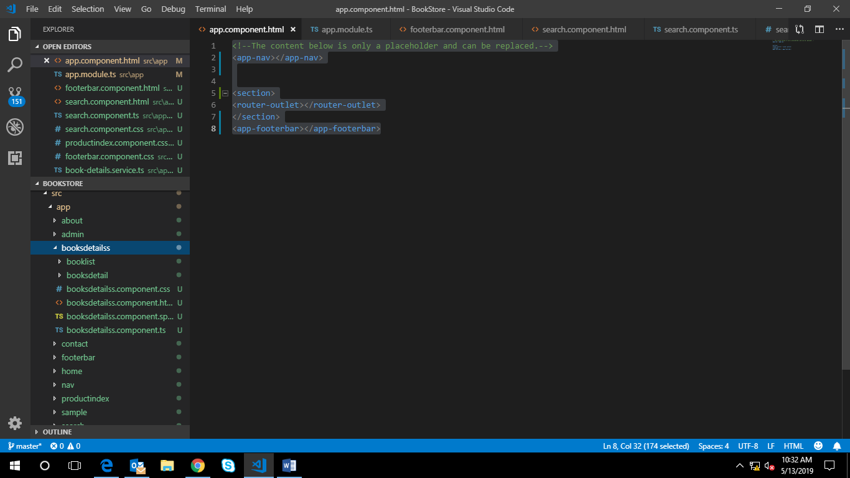

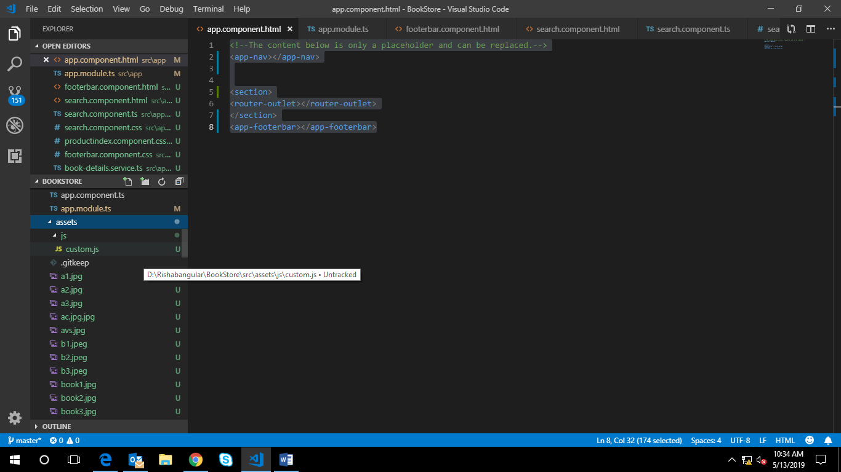

15styles.css

/* You can add global styles to this file, and also import other style files */

@import "~ngx-toastr/toastr.css";

@import url('https://fonts.googleapis.com/css?family=Montserrat:400,700');

16. index.html

<!doctype html>

<html lang="en">

<head>

<meta charset="utf-8">

<title>BookStore</title>

<base href="/">

<meta name="viewport" content="width=device-width, initial-scale=1">

<link rel="icon" type="image/x-icon" href="favicon.ico">

<script src="https://ajax.googleapis.com/ajax/libs/jquery/3.4.0/jquery.min.js"></script>

<script src="https://maxcdn.bootstrapcdn.com/bootstrap/3.4.0/js/bootstrap.min.js"></script>

<link rel="stylesheet" href="https://maxcdn.bootstrapcdn.com/bootstrap/3.4.0/css/bootstrap.min.css">

<link rel="stylesheet" href="https://cdnjs.cloudflare.com/ajax/libs/font-awesome/4.7.0/css/font-awesome.min.css">

</head>

<body>

<app-root></app-root>

</body>

</html>

17.

Cors file

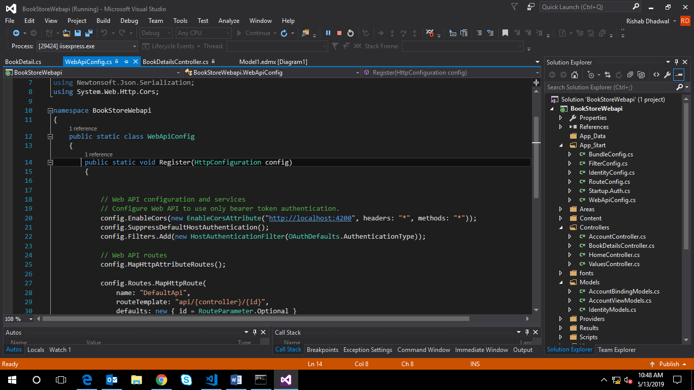

***Snap Shots***



Homepage

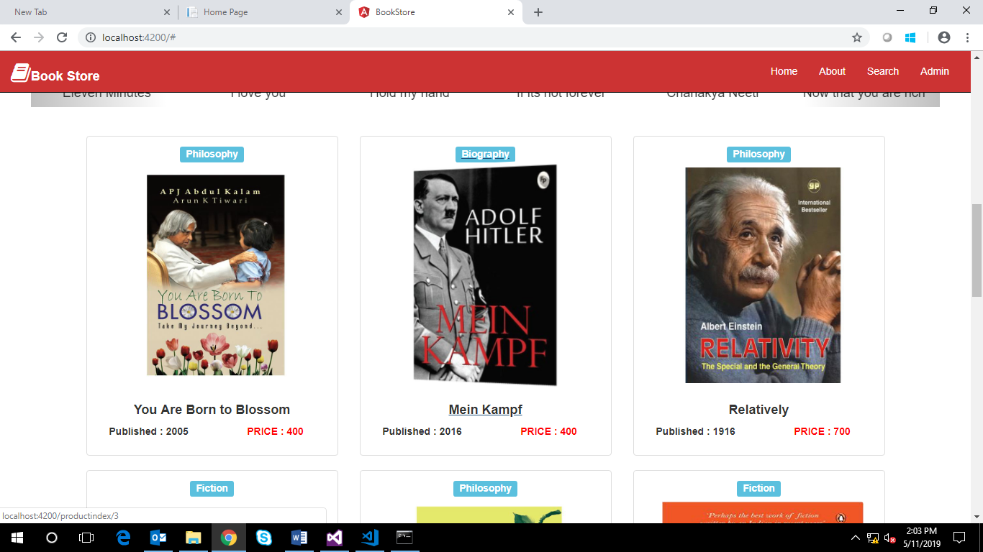

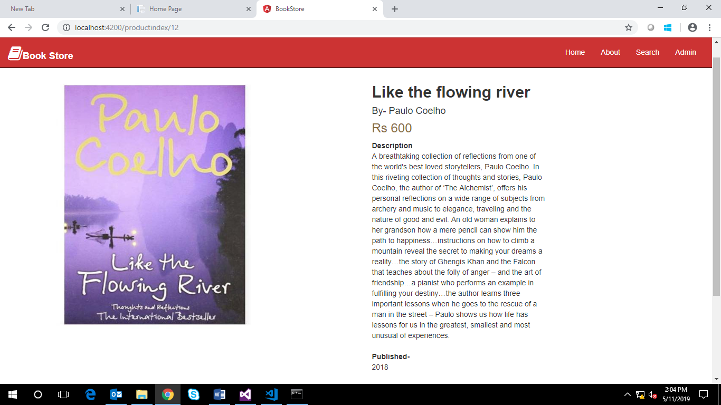

Product detail page

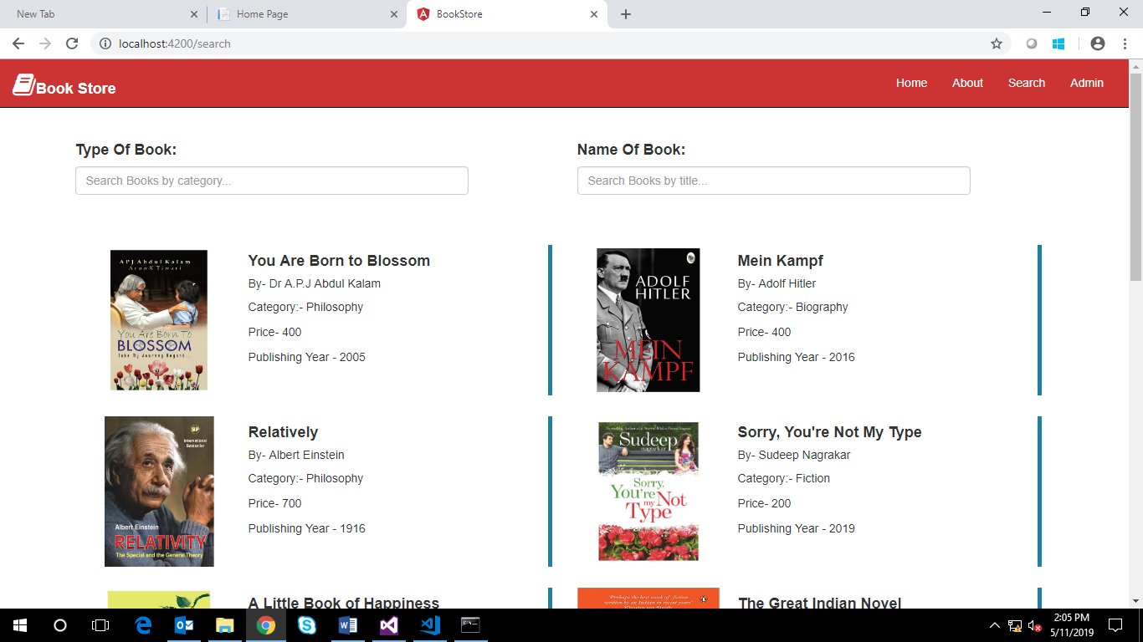

Filter page (Search)

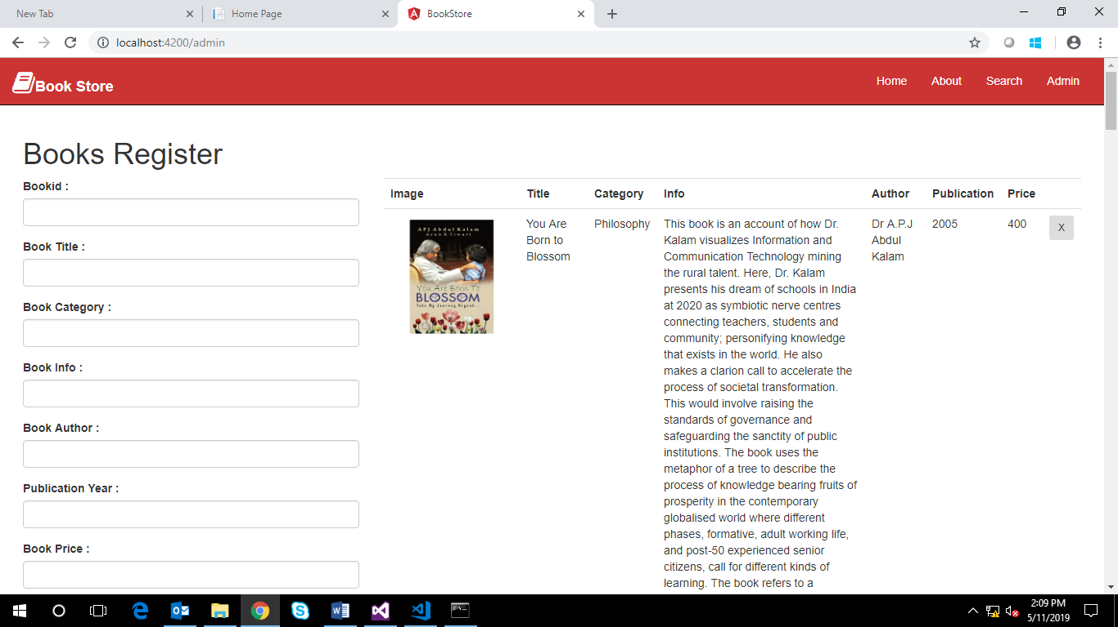

Admin page performs CRUD operations

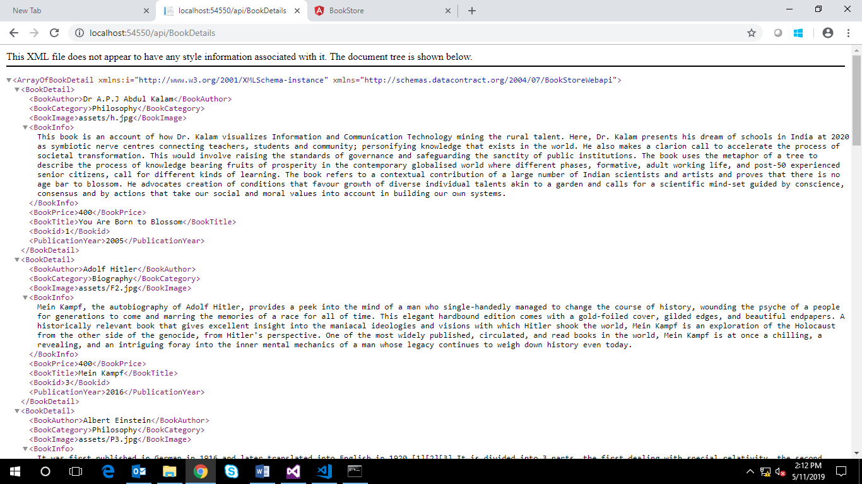

Web API

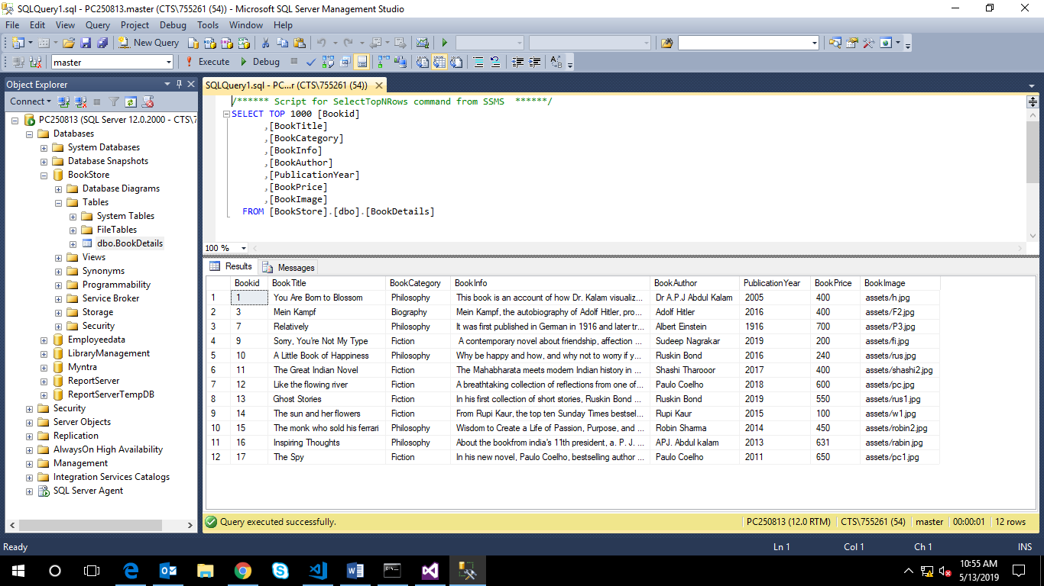

Database Bookstore